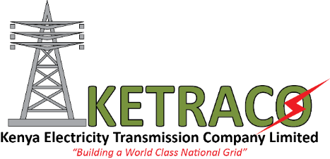

KETRACO PARTNERS WITH KENYATTA UNIVERSITY TO BRIDGE ENGINEERING SKILL GAP
Nairobi, 24th June 2019
The Kenya Electricity Transmission Company Limited (KETRACO) has partnered with Kenyatta University (KU) to bridge the engineering skill gap and form a link that will see the development of new products and technology in electricity transmission through scholarships, research funding and knowledge management consultation.
The scholarship, dubbed KETRACO Scholarship for Orphans & Vulnerable Students (KETSOVS) will see KETRACO give Kshs. I million worth scholarship to educate two orphan or vulnerable students in Electric or Civil Engineering faculty for five years. The transmission company will also be bronze sponsors of KU’s Biennial Research and Innovation Conference 2019.
Moreover, the partnership will enable KETRACO to partner with the university’s Capacity Development and Consultancy Services Directorate to guide the transmission company on Knowledge Management.
Speaking during the Memorandum of Understanding (MoU) signing ceremony, KETRACO’s MD, FCPA Fernandes Barasa noted that this is one of the initiatives that the transmission company has engaged in with leading institutions of higher education to fulfil its vision of being a world-class electricity transmission company and the leading interconnector in Africa.
“This partnership will facilitate mutual collaboration between us and KU that will enable us explore emerging trends in electricity transmission and research,” FCPA Barasa added.

ENDS

About KETRACO
KETRACO is a 100% state-owned corporation incorporated in December 2008, under the Company’s Act Cap 486. Its mandate is to plan, design, construct, own, operate and maintain high voltage (132kV and above) national electricity transmission grid and regional power interconnectors, in line with Kenya Vision 2030.
KETRACO projects are undertaken based on the following themes: - Electricity Access Projects, System Strengthening Projects, Power Evacuation Projects and Regional Interconnection Projects.
Since 1954 when the first 220kV line between Nairobi and Jinja (Owen Falls) was constructed, only about 4000 kilometres of high voltage transmission network is in place to date. KETRACO will construct another 5000 kilometres in the next four years focussing on strengthening the existing Transmission System, penetrating into new generation & load distribution areas and enhancing Regional Inter-connections with Uganda, Tanzania and Ethiopia.

About KU
XXX

