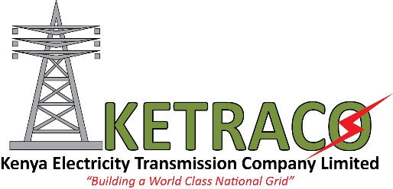
For immediate release:
-ELECTRICITY TO KONZA TECHNO CITY IS READY
Nairobi, 9th August 2016
The Kenya Electricity Transmission Company Limited (KETRACO)’s substation at Konza City Techno has been energized. The substation, which is part of the Machakos – Konza project will supply electricity to Konza and Machakos environs. The energization will increase reliability and improve power quality to the areas by providing alternative electricity supply and shortening the length of the existing Athi River – Salama feeder. The project is financed by the Government of Kenya and EXIM Bank at a total cost of USD 13 Million.
With a rating of 73MW, the 12Km Machakos – Konza transmission line involved the construction of 132kV single circuit line and two 132/33kV substations at Machakos and Konza. Konza substation will tap a mixture of hydro, geothermal and thermal power through Loop-In-Loop-Out (LILO) arrangement from the existing Juja – Rabai line.
Areas to be fed include Kyumvi, Salama, Athi River and Iposalat from Konza Substation. At Machakos substation, the power will further be fed to four 33kV line feeders; Kola, Konza, Katangi, Machakos and two future feeder lines.
Speaking during the energization exercise, KETRACO’s Ag. GM Technical Services Dr. (Eng.) John Mativo said that investors from within and outside the country can now invest in Information and Communication Technology (ICT), Health, Tourism and Agriculture sectors among others as they are assured of reliable, efficient and affordable power supply.
“Machakos County will become more than a technical and industrious hub it envisions to be. Konza Techno City, Hospitalsand Small-Scale businesses such as Jua Kali and saloons are among the industries that depend on power availability and will benefit from the high voltage power we are transmitting to this County.” Dr. (Eng.) Mativo added.
Other projects the Company has implemented include the 220kVRabai – Malindi – Garsen – Lamu (TMGL) transmission line that will power the Lamu Port South Sudan Ethiopia Transport (LAPSSET) corridor and the Mombasa – Nairobi line that will power the Standard Gauge Railway (SGR) upon its completion later this year.
By 2030, KETRACO will have implemented transmission infrastructure totaling to 16,000km of high voltage transmission lines that are in line with the Vision.The transmission lines, substations and switch gears will facilitate electricity evacuation from generating stations, reinforce the grid network for increased capacity, reliability and provide redundancy.
About KETRACO
The Electricity Transmission Company Limited (KETRACO) is a 100% state-owned corporation incorporated in December 2008, under the Company’s Act Cap 486. Its mandate is to plan, design and construct, own, operate and maintain high voltage electricity transmission grid and regional power interconnectors. This infrastructure forms the backbone of the National Transmission Grid, in line with Kenya Vision 2030; with the aim of shielding electricity consumers from the higher retail tariffs.
KETRACO projects are undertaken based on the following themes: Electricity Access Projects, System Strengthening Projects, Power Evacuation Projects and Regional Interconnection Projects.

KETRACO is currently constructing a total of about 3,500Km of transmission line with the major projects being the 400kV Mombasa- Nairobi Line, 220kV Olkaria- Suswa amongst others. The Company is also constructing lines to connect the Region and they include the 500kV Ethiopia- Kenya Line, 220kV Lessos- Tororo and the 400kV Kenya Tanzania Line.

Another major project for the Company is Suswa Substation. This is the biggest substation in the country and is the connection point for the 500kV Ethiopia Kenya Project and the 400kV Isinya- Suswa transmission line. The reach of this line will later expand to as far as Tanzania and Zambia through the Kenya- Tanzania line.

For more information contact
Raphael Mworia
Manager Corporate Communications
KETRACO
0702-949951/020-4956210
rmworia@ketraco.co.ke
www.ketraco.co.ke

