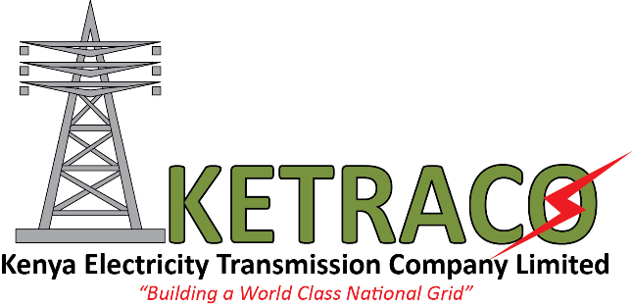
PRESS RELEASE

For immediate Release:
KETRACO GROUNDBREAKS COMMUNITY PROJECTS IN MARSABIT
Marsabit: 31st July, 2018
The Kenya Electricity Transmission Company Limited (KETRACO) today initialized a two day ground breaking ceremonies exercise for community projects in Marsabit County. This is in line with the 686Km 500kV HVDC Ethiopia Kenya Power Interconnector (Eastern Electricity Highway Project) that runs from Woloyta/Sodo in Ethiopia to Suswa substation in Kenya.
The transmission project traverses a 263Km stretch of communally owned land across Marsabit County where the Company will put up 13 community projects financed via the compensation for limited loss of land use. These ceremonies mark their kick offs in Laisamis and North Horr constituencies on 31st July and 1st August respectively.
Speaking during the first ceremony at Laisamis Primary School, KETRACO’S Managing Director, FCPA, Fernandes Barasa affirmed that the Company is working towards increasing electricity access, effectively evacuating generated power and facilitating regional power trade.
“In addition to fulfilling its mandate, KETRACO is always working towards engaging communities traversed by its projects. In this case where land is owned communally, the community affected was asked to collectively pick a project of choice to be initiated in place of compensation,” stated FCPA Barasa.
FCPA Barasa further noted that the Company is also dedicated to improvement of human life and is committed to help where possible for the good of its customers. “With the building of classrooms in this school, we anticipate a developed community. We are happy to be part of this important growth that is in line with the achievement of the Big 4 agenda by supporting pupils and students who will be tomorrow’s leaders,” he added.
The Ethiopia Kenya Power Interconnector was conceived in 2006 when Ethiopia and Kenya signed a memorandum of understanding that allowed for the establishment of a power system interconnection between the systems of Ethiopia and Kenya.
The Ethiopia Kenya Power Interconnector is divided into lots. The project contractors are: Siemens and Isolux for the Converter Station, KEC International of India (Lot 4), Larsen & Toubro of India (Lot 5) and Kalpataru Power Transmission of India (Lot 6). This project is jointly funded by African Development Bank (AfDB), French Development Agency (AFD), World Bank and the Government of Kenya at a cost of Kshs. 42.5 billion. It is scheduled to be completed in March 2019.
Upon its completion, this project is expected to generate investment opportunities in electricity infrastructure and also give rise to development of other related industries.

For more information contact
Raphael Mworia
Manager Corporate Communications
KETRACO
0702-949951
rmworia@ketraco.co.ke
www.ketraco.co.ke

